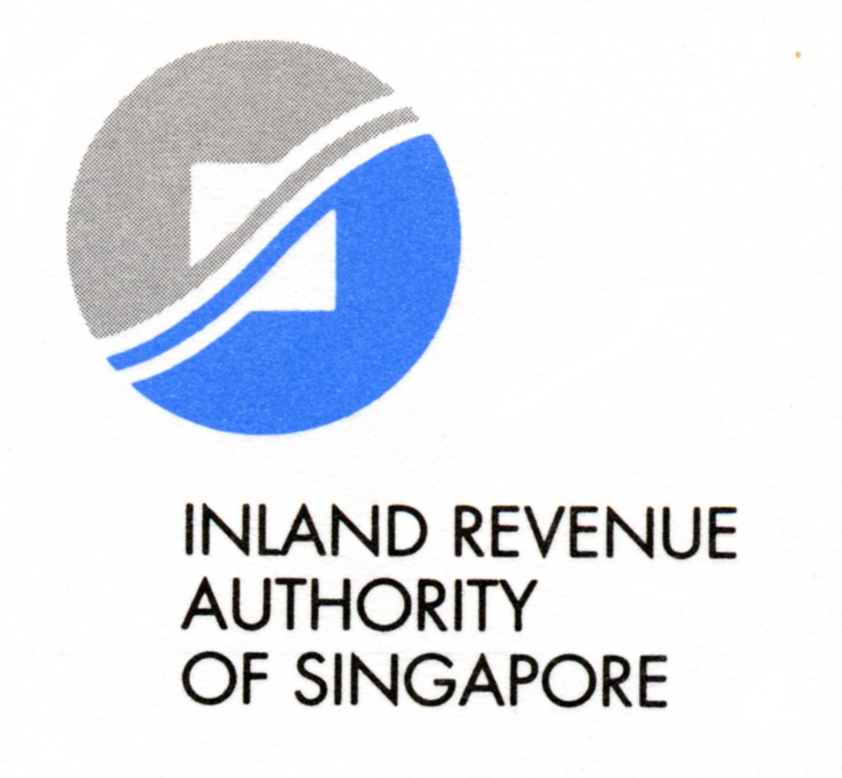
Application For Resident Status For Public Entertainers
This form is to be completed by a non-resident public entertainer applying for resident status.
此表用于从事演艺的非居民纳税人申请成为居民纳税人

Under the Singapore Income Tax Act, there are penalties for making a false or incorrect declaration.
根据新加坡国内税务条例,虚报或呈报不正确资料的人士将受到处罚.
* Please delete where applicable (*请删除不正确的资料)
F08-01

It may take you 3 minutes to fill in this form. Please get ready your particulars e.g. identification card, passport and engagement details.
填写此表格只需三分钟时间。请准备您的个人资料, 例如: 工作准证卡, 护照以及驻唱详情。

Section A : Your Personal Particulars (纳税人个人详情)
Full Name Of Entertainer (as in passport) (纳税人姓名–依照护照上的姓名填写): |  | FIN (外国号码)/ Passport No (护照号):
Address (地址): |  | Contacts  (联络方式): ___________________________________  Email address  (电邮网址): ___________________________________  Telephone  (联系电话): ___________________________________
Date Of Birth (出生日期): | Sex(性别):Male(男) / Female(女) | Nationality (国籍):

Section B: Application for Resident Status (申请成为居民纳税人)

(You are regarded as a resident if you performed or stayed in Singapore for 183 days or more in a calendar year. All applications must be supported by Forms IR37D filed by the payers previously)
如果演艺者在一年讷(1月1日至12月31日)表演或住满183天或以上，将被当成居民纳税人。纳税人必须填妥此表格，并附上公司所呈报的IR37D表格。)
I wish to apply for resident status for the following year(s), my schedule of days in Singapore is as follows:
本人愿申请成为新加坡居民纳税人. 逗留在新加坡的详情如：
Year  年度 | Date of arrival  入境日期 -日/月/年 | Date of departure#  出境日期 -日/月/年# | No of days  逗留天数 | Income  入息
 |  | Total (合计)

# if date of departure is not applicable, please state name and address of new sponsor and engagement period :
(如尚未离境, 请写下相关公司名称，地址及表演档期.)

Section C: Claim For Refund (√ as appropriate for the mode of refund.) (请在适当空格注上√ 号.)
- via cheque to be posted to: (以支票方式寄至:)
- local address : ____________________________________________________________________________________
(本地邮址)
- overseas address:_________________________________________________________________________________
(海外邮址)

- via cheque to be collected personally. My contacts are as Section A.
(本人欲自领取现金支票。请根据以上述所提供资料 联络本人)

- Refund via Bank Draft:
请将款项通过银行汇票退款：
Overseas address: _______________________________________________________________________________________
(海外邮址)
_______________________________________________________________________________________
Currency type:
(货币型)* _______________________________________________________________________________________
*(The bank draft will be issued in US dollars if the requested currency is not available.)
*(请注意如果我们无法处理您所要求的货币，我们将发出美元的银行汇票.)

I, __________________________________ agree to bear all the bank charges for the Bank Draft.
本人同意承担全部银行汇票 的银行收费。

Section D : Your Declaration 纳税人宣誓
I, hereby declare that all information given in this form and in any documents attached is true, correct and complete.
本人谨此证明在此份表格中有关的资料及所附呈之任何文件均详实无误。
Date (申请日期 – 日/月/年)
Signature (纳税人签字)

